**(EEL2020)** **DIGITAL DESIGN LAB2 REPORT**

KARTIK CHOUDHARY B20CS025

1. Write a program to implement (with test benches)  
   a) Binary to Gray Code Converter.

TEST BENCH

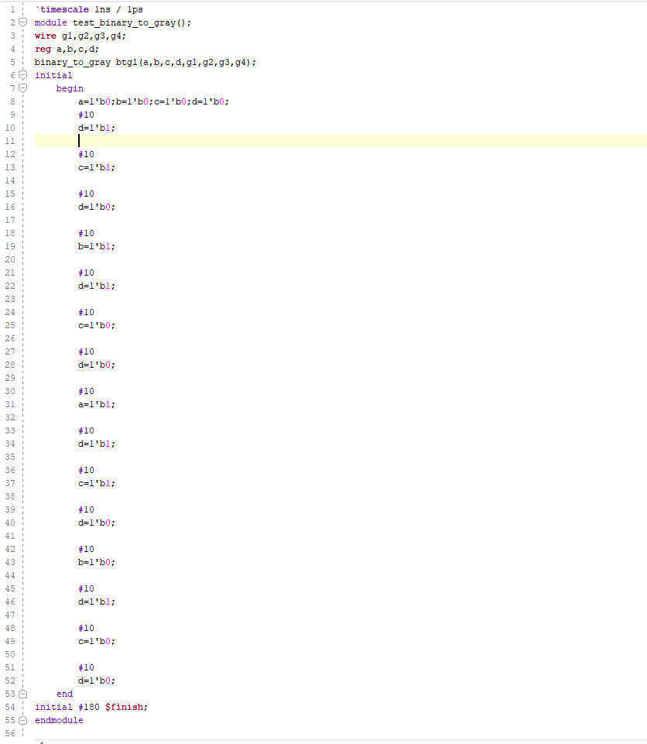

VERILOG CODE

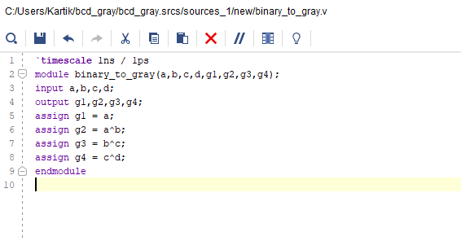

SIMULATED WAVEFORM to get the four-bit binary gray code g4 g3 g2 g1

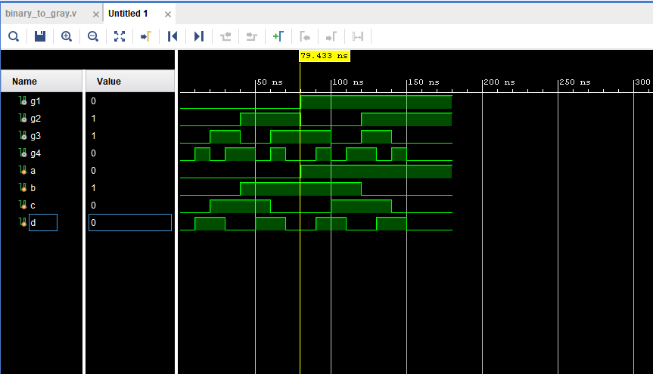

b) Gray code to Binary code Converter.

TEST BENCH

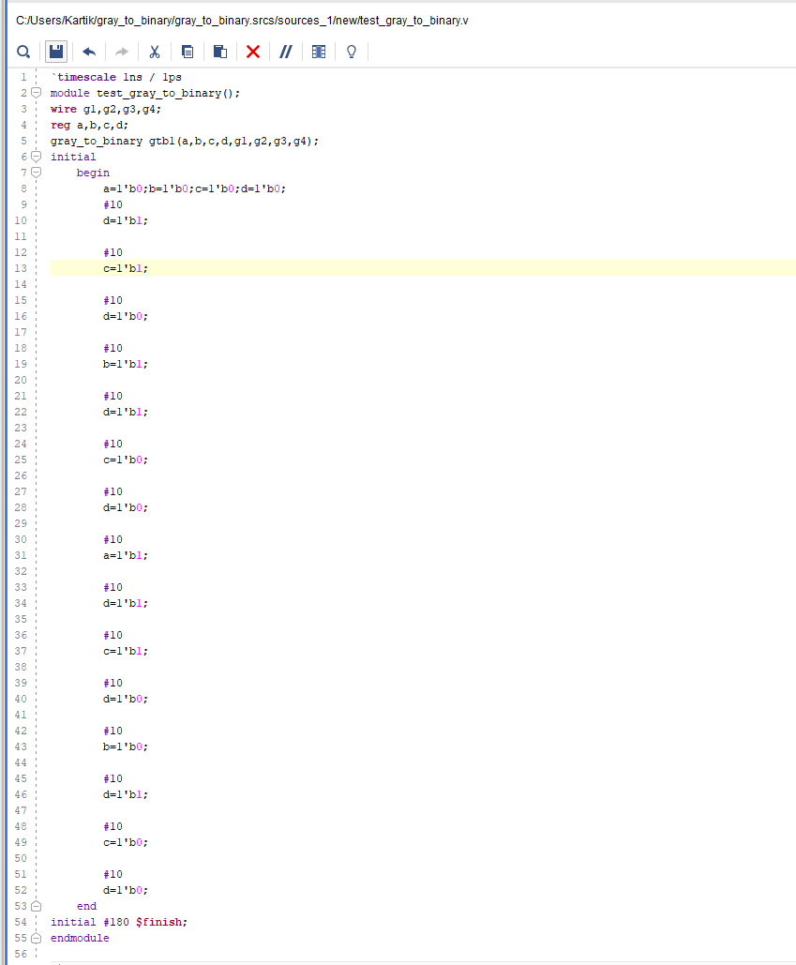

VERILOG CODE

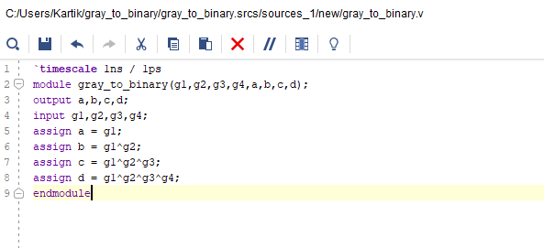

SIMULATED WAVEFORM

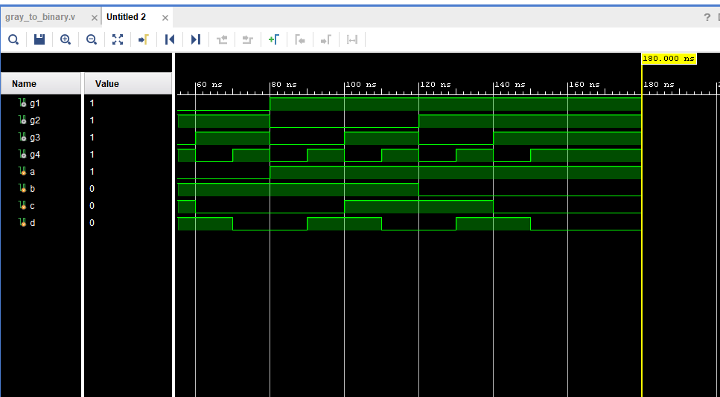

1. Write a program to implement a BCD to 7-segment display decoder.

VERILOG CODE

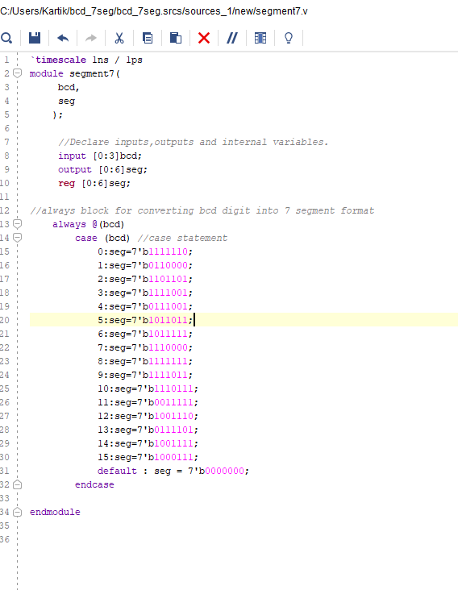

1. Implement a Buzzer system in Verilog. Write test bench and verify various cases.

TEST BENCH

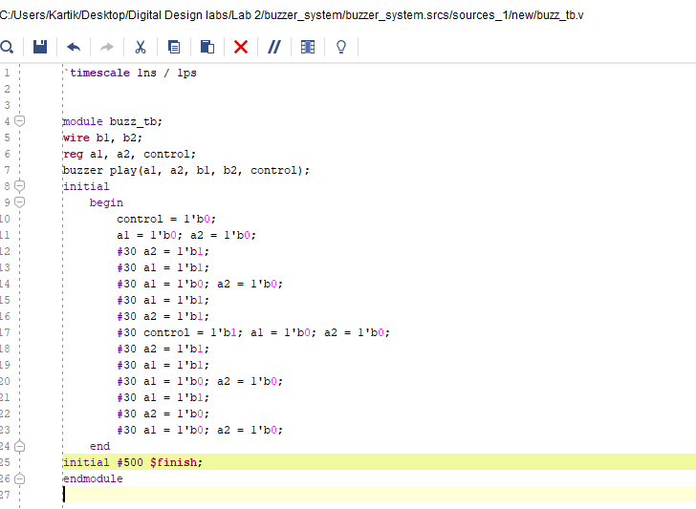

VERILOG

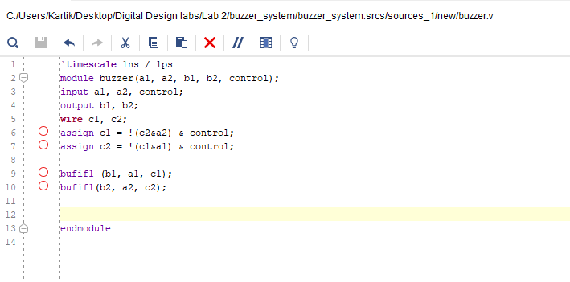

WAVEFORM

